EmberJS 5.12

# Setup

## Visual Studio Code

<https://code.visualstudio.com/>

## Git for Windows

<https://gitforwindows.org/>

<https://git-scm.com/downloads/win>

## NodeJS

<https://nodejs.org/en/>

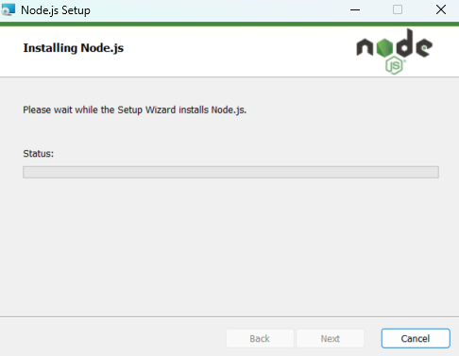

C:\Program Files\nodejs\

## NVM for Windows

<https://www.freecodecamp.org/news/node-version-manager-nvm-install-guide/>

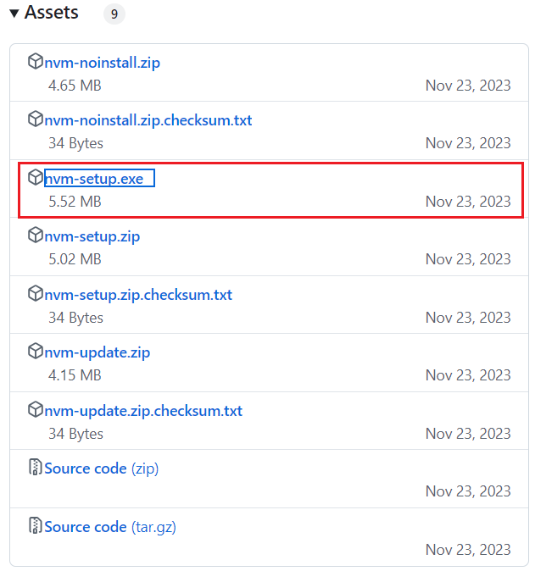

C:\Users\ADMIN\AppData\Roaming\nvm

C:\Program Files\nodejs

nvm use 20.18.0

npm install -g yarn

nvm use 18.0.0

npm install -g yarn

nvm use 14.0.0

npm install -g yarn

nvm use 12.0.1

npm install -g yarn

## Setup npm

## Setup yarn

## Setup bower

## Check installed Ember versions

PS D:\Ember512> node --version

v20.18.0

PS D:\Ember512> npm --version

10.3.0

PS D:\Ember512> ember --version

ember-cli: 5.12.0

node: 20.18.0

os: win32 x64

D:\Ember512> ember new my-app-name

installing app

**Ember CLI v5.12.0**

Creating a new Ember app in D:\Ember512\my-app-name:

**create** .editorconfig

**create** .ember-cli

**create** .eslintignore

**create** .eslintrc.js

**create** .github\workflows\ci.yml

**create** .prettierignore

**create** .prettierrc.js

**create** .stylelintignore

…

Installing packages... This might take a couple of minutes.

**npm: Installed dependencies**

Initializing git repository.

**Git: successfully initialized.**

Successfully created project my-app-name.

Get started by typing:

$ **cd my-app-name**

$ **npm start**

Happy coding!

PS D:\Ember512>

D:\Ember512> cd my-app-name

D:\Ember512\my-app-name> ember server

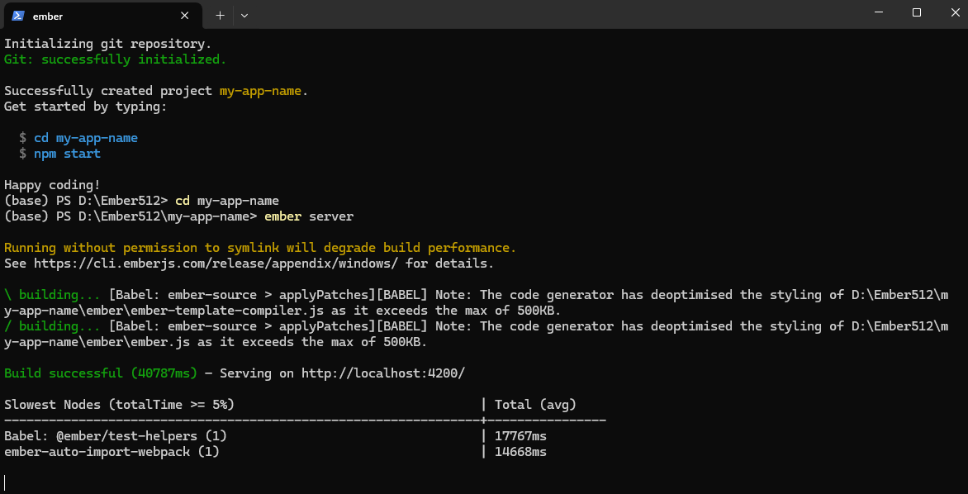

PS D:\Ember512\my-app-name> npm install

PS D:\Ember512\my-app-name> ember server

PS D:\Ember512\my-app-name> ember serve

PS D:\Ember512\my-app-name> ember serve --port=8080

PS D:\Ember512\my-app-name> ember s

PS D:\Ember512\my-app-name> code .

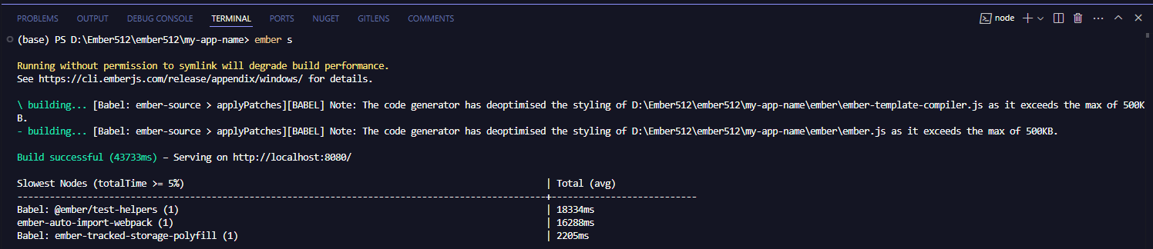

## Ember CLI

<https://cli.emberjs.com/release/appendix/windows/>

## Step by Step

### Create route

D:\Ember512\my-app-name> ember generate route users

# EmberJS 5.12

npm install ember-cli

ember new my-app-name

# LTS

# Install Ember 5.8.0:

npm install --save-dev ember-source@~5.8.0

# Install Ember Data 5.3.0:

npm install --save-dev ember-data@~5.3.0

# Samples

<https://hospitalrun.io>

<https://github.com/HospitalRun>

Ember front end for HospitalRun

<https://github.com/LowBP/hospitalrun>

<https://github.com/gtechsltn/HospitalRun>

# Guide: How to?

### How to run ember from a different port other than 4200?

<https://stackoverflow.com/questions/44274656/can-i-serve-my-localhost-from-a-different-port-other-than-4200-in-emberjs>

### Ember server port 4200 is already in use?

<https://stackoverflow.com/questions/51755399/ember-server-port-4200-is-already-in-use-when-no-process-runs-on-4200>